3.2.1 Cumulative Distribution Function
The PMF is one way to describe the distribution of a discrete random variable. As we will see later on, PMF cannot be defined for continuous random variables. The cumulative distribution function (CDF) of a random variable is another method to describe the distribution of random variables. The advantage of the CDF is that it can be defined for any kind of random variable (discrete, continuous, and mixed).

Definition
The cumulative distribution function (CDF) of random variable X is defined as

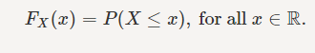

Note that the subscript X� indicates that this is the CDF of the random variable X�. Also, note that the CDF is defined for all x∈R�∈�. Let us look at an example.

Example
I toss a coin twice. Let X� be the number of observed heads. Find the CDF of X�.
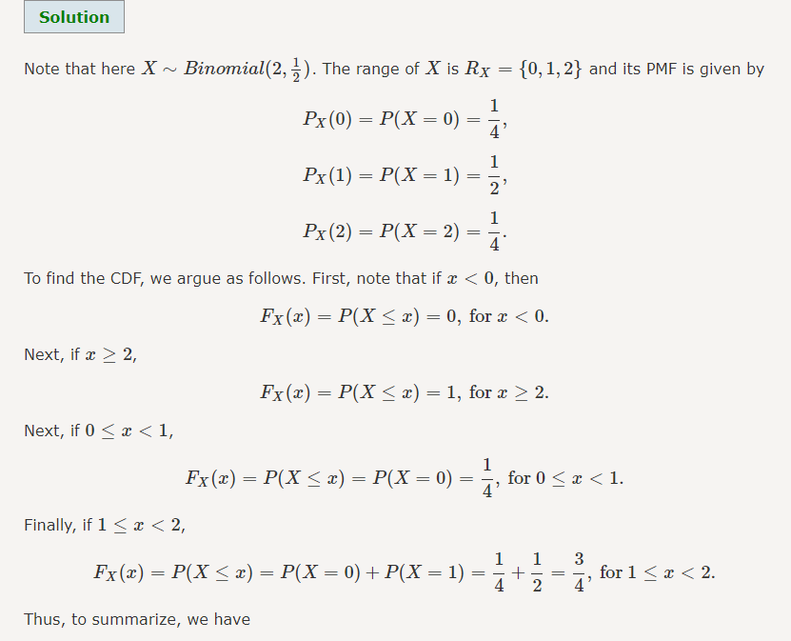

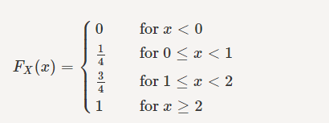

Note that when you are asked to find the CDF of a random variable, you need to find the function for the entire real line. Also, for discrete random variables, we must be careful when to use "<<" or "≤≤". Figure 3.3 shows the graph of FX(x)��(�). Note that the CDF is flat between the points in RX�� and jumps at each value in the range. The size of the jump at each point is equal to the probability at that point. For, example, at point x=1�=1, the CDF jumps from 1414 to 3434. The size of the jump here is 34−14=1234−14=12 which is equal to PX(1)��(1). Also, note that the open and closed circles at point x=1�=1 indicate that FX(1)=34��(1)=34 and not 1414.

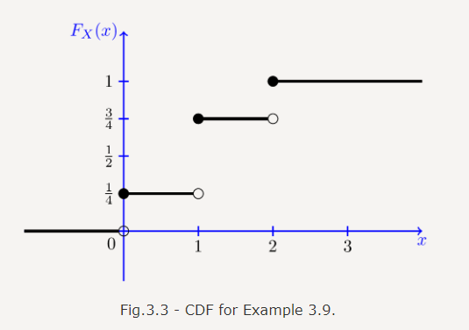

n general, let X� be a discrete random variable with range RX={x1,x2,x3,...}��={�1,�2,�3,...}, such that x1<x2<x3<...�1<�2<�3<... Here, for simplicity, we assume that the range RX�� is bounded from below, i.e., x1�1 is the smallest value in RX��. If this is not the case then FX(x)��(�) approaches zero as x→−∞�→−∞ rather than hitting zero. Figure 3.4 shows the general form of the CDF, FX(x)��(�), for such a random variable. We see that the CDF is in the form of a staircase. In particular, note that the CDF starts at 00; i.e.,FX(−∞)=0��(−∞)=0. Then, it jumps at each point in the range. In particular, the CDF stays flat between xk�� and xk+1��+1, so we can write

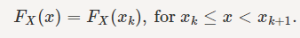

The CDF jumps at each xk��. In particular, we can write

Thus, the CDF is always a non-decreasing function, i.e., if y≥x�≥� then FX(y)≥FX(x)��(�)≥��(�). Finally, the CDF approaches 11 as x� becomes large. We can write

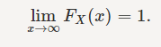
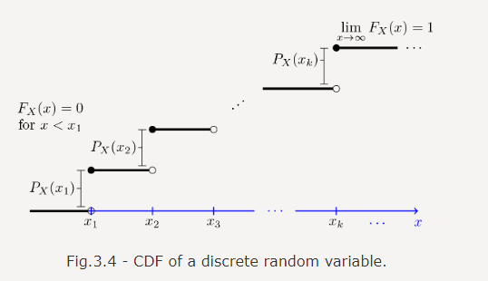

Note that the CDF completely describes the distribution of a discrete random variable. In particular, we can find the PMF values by looking at the values of the jumps in the CDF function. Also, if we have the PMF, we can find the CDF from it. In particular, if RX={x1,x2,x3,...}��={�1,�2,�3,...}, we can write

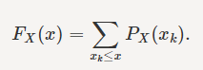

Now, let us prove a useful formula.



To see this, note that for a≤b we have
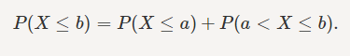
Thus,
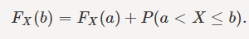

Again, pay attention to the use of "<<" and "≤≤" as they could make a difference in the case of discrete random variables. We will see later that Equation 3.1 is true for all types of random variables (discrete, continuous, and mixed). Note that the CDF gives us P(X≤x)�(�≤�). To find P(X<x)�(�<�), for a discrete random variable, we can simply write

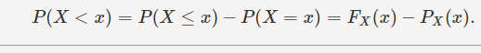

Example
Let X� be a discrete random variable with range RX={1,2,3,...}��={1,2,3,...}. Suppose the PMF of X� is given by

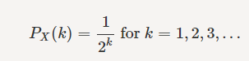

- Find and plot the CDF of X�, FX(x)��(�).
- Find P(2<X≤5)�(2<�≤5).
- Find P(X>4)
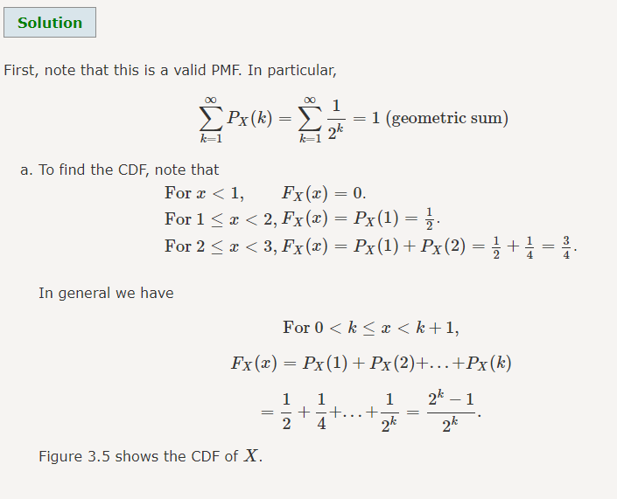

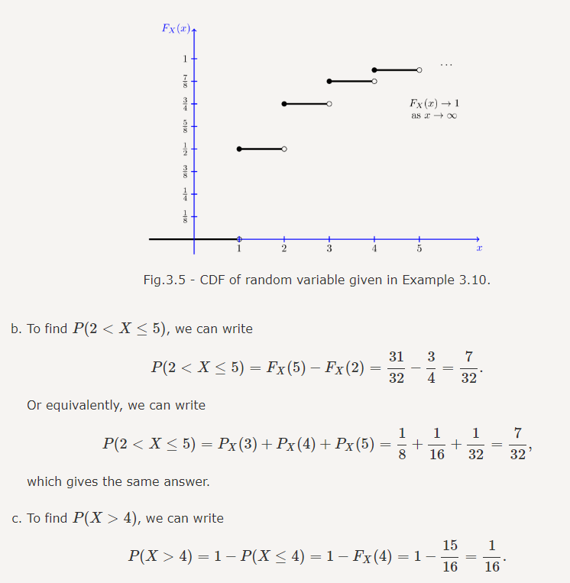

3.2.2 Expectation
If you have a collection of numbers a1,a2,...,aN�1,�2,...,��, their average is a single number that describes the whole collection. Now, consider a random variable X�. We would like to define its average, or as it is called in probability, its expected value or mean. The expected value is defined as the weighted average of the values in the range.

Expected value (= mean=average):
Definition
Let X� be a discrete random variable with range RX={x1,x2,x3,...}��={�1,�2,�3,...} (finite or countably infinite). The expected value of X�, denoted by EX�� is defined as
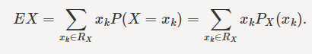

To understand the concept behind EX��, consider a discrete random variable with range RX={x1,x2,x3,...}��={�1,�2,�3,...}. This random variable is a result of random experiment. Suppose that we repeat this experiment a very large number of times N�, and that the trials are independent. Let N1�1 be the number of times we observe x1�1, N2�2 be the number of times we observe x2�2, ...., Nk�� be the number of times we observe xk��, and so on. Since P(X=xk)=PX(xk)�(�=��)=��(��), we expect that

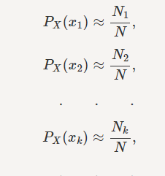

In other words, we have Nk≈NPX(xk)��≈���(��). Now, if we take the average of the observed values of X�, we obtain

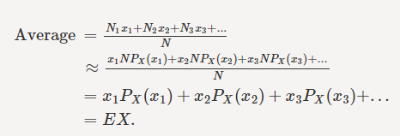

Thus, the intuition behind EX�� is that if you repeat the random experiment independently N� times and take the average of the observed data, the average gets closer and closer to EX�� as N� gets larger and larger. We sometimes denote EX�� by μX��.

Different notations for expected value of X�: EX=E[X]=E(X)=μX��=�[�]=�(�)=��.

Let's compute the expected values of some well-known distributions.
Example
Let X∼Bernoulli(p)�∼���������(�). Find EX��.

- For the Bernoulli distribution, the range of X� is RX={0,1}��={0,1}, and PX(1)=p��(1)=� and PX(0)=1−p��(0)=1−�. Thus,
EX�� | =0⋅PX(0)+1⋅PX(1)=0⋅��(0)+1⋅��(1)
 | =0⋅(1−p)+1⋅p=0⋅(1−�)+1⋅�
 | =p=�.

For a Bernoulli random variable, finding the expectation EX�� was easy. However, for some random variables, to find the expectation sum, you might need a little algebra. Let's look at another example.

Example
Let X∼Geometric(p)�∼���������(�). Find EX��.

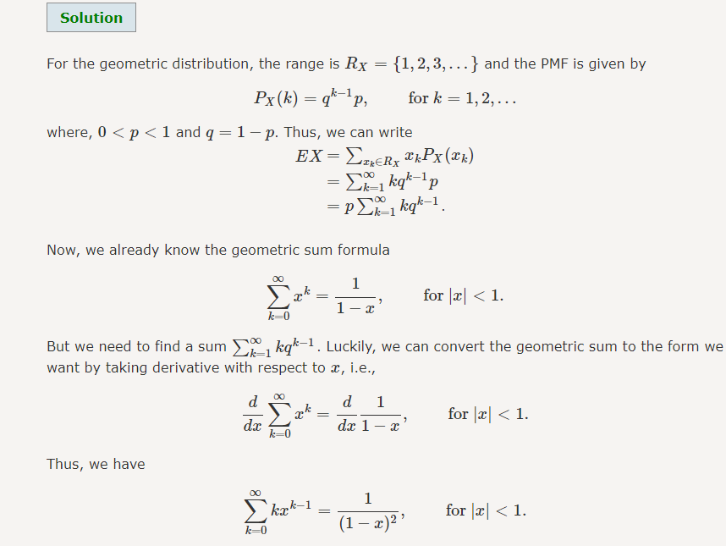

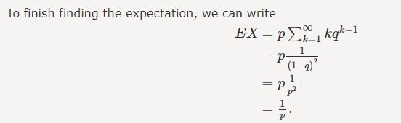

So, for X∼Geometric(p)�∼���������(�), EX=1p��=1�. Note that this makes sense intuitively. The random experiment behind the geometric distribution was that we tossed a coin until we observed the first heads, where P(H)=p�(�)=�. Here, we found out that on average you need to toss the coin 1p1� times in this experiment. In particular, if p� is small (heads are unlikely), then 1p1� is large, so you need to toss the coin a large number of times before you observe a heads. Conversely, for large p� a few coin tosses usually suffices.

Example
Let X∼Poisson(λ)�∼�������(�). Find EX��.

Before doing the math, we suggest that you try to guess what the expected value would be. It might be a good idea to think about the examples where the Poisson distribution is used. For the Poisson distribution, the range is RX={0,1,2,⋯}��={0,1,2,⋯} and the PMF is given by

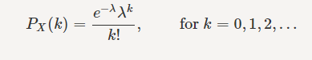

Thus, we can write

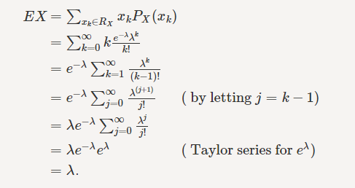
So the expected value is λ�. Remember, when we first talked about the Poisson distribution, we introduced its parameter λ� as the average number of events. So it is not surprising that the expected value is EX=λ��=�.
--------------------------------------------------------------------------------------------------------------------------------
Before looking at more examples, we would like to talk about an important property of expectation, which is linearity. Note that if X� is a random variable, any function of X� is also a random variable, so we can talk about its expected value. For example, if Y=aX+b�=��+�, we can talk about EY=E[aX+b]��=�[��+�]. Or if you define Y=X1+X2+⋯+Xn�=�1+�2+⋯+��, where Xi��'s are random variables, we can talk about EY=E[X1+X2+⋯+Xn]��=�[�1+�2+⋯+��]. The following theorem states that expectation is linear, which makes it easier to calculate the expected value of linear functions of random variables.
Expectation is linear:
Theorem
We have

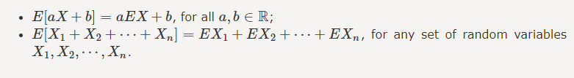

We will prove this theorem later on in Chapter 5, but here we would like to emphasize its importance with an example.

Example
Let X∼Binomial(n,p)�∼��������(�,�). Find EX��.

We provide two ways to solve this problem. One way is as before: we do the math and calculate EX=∑xk∈RXxkPX(xk)��=∑��∈������(��) which will be a little tedious. A much faster way would be to use linearity of expectation. In particular, remember that if X1,X2,...,Xn�1,�2,...,�� are independent Bernoulli(p)���������(�) random variables, then the random variable X� defined by X=X1+X2+...+Xn�=�1+�2+...+�� has a Binomial(n,p)��������(�,�) distribution. Thus, we can write

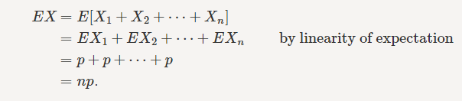

We will provide the direct calculation of EX=∑xk∈RXxkPX(xk)��=∑��∈������(��) in the Solved Problems section and as you will see it needs a lot more algebra than above. The bottom line is that linearity of expectation can sometimes make our calculations much easier. Let's look at another example.

Example
Let X∼Pascal(m,p)�∼������(�,�). Find EX��. (Hint: Try to write X=X1+X2+⋯+Xm�=�1+�2+⋯+��, such that you already know EXi���.)

We claim that if the Xi��'s are independent and Xi∼Geometric(p)��∼���������(�), for i=1�=1, 22, ⋯⋯, m�, then the random variable X� defined by X=X1+X2+⋯+Xm�=�1+�2+⋯+�� has Pascal(m,p)������(�,�). To see this, you can look at Problem 5 in Section 3.1.6 and the discussion there. Now, since we already know EXi=1p���=1�, we conclude

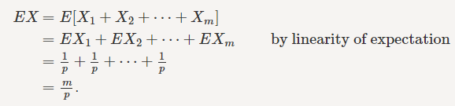

Again, you can try to find EX�� directly and as you will see, you need much more algebra compared to using the linearity of expectation.

3.2.3 Functions of Random Variables
If X� is a random variable and Y=g(X)�=�(�), then Y� itself is a random variable. Thus, we can talk about its PMF, CDF, and expected value. First, note that the range of Y� can be written as
RY={g(x)|x∈RX}.��={�(�)|�∈��}.
If we already know the PMF of X�, to find the PMF of Y=g(X)�=�(�), we can write
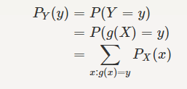
Let's look at an example.
Example
Let X� be a discrete random variable with PX(k)=15��(�)=15 for k=−1,0,1,2,3�=−1,0,1,2,3. Let Y=2|X|�=2|�|. Find the range and PMF of Y�.
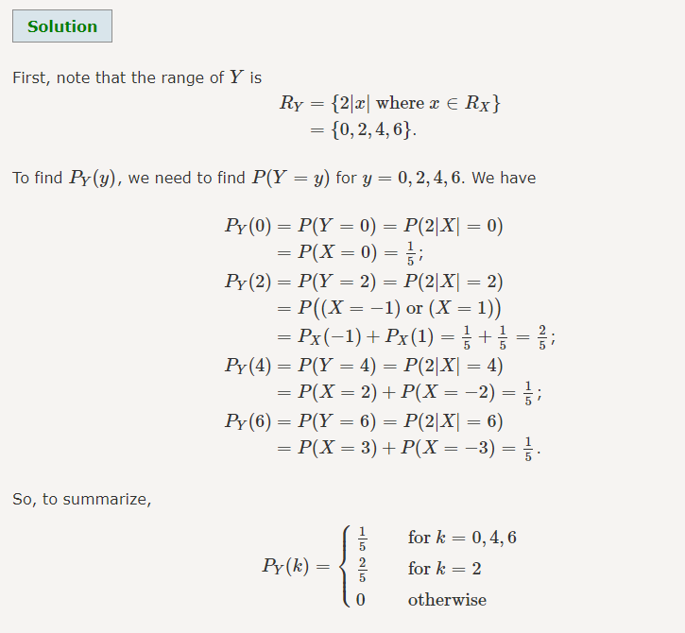

Expected Value of a Function of a Random Variable (LOTUS)
Let X� be a discrete random variable with PMF PX(x)��(�), and let Y=g(X)�=�(�). Suppose that we are interested in finding EY��. One way to find EY�� is to first find the PMF of Y� and then use the expectation formula EY=E[g(X)]=∑y∈RYyPY(y)��=�[�(�)]=∑�∈�����(�). But there is another way which is usually easier. It is called the law of the unconscious statistician (LOTUS).

Law of the unconscious statistician (LOTUS) for discrete random variables:

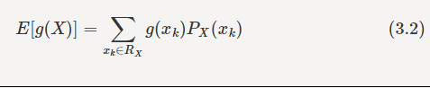
You can prove this by writing EY=E[g(X)]=∑y∈RYyPY(y)��=�[�(�)]=∑�∈�����(�) in terms of PX(x)��(�). In practice it is usually easier to use LOTUS than direct definition when we need E[g(X)]�[�(�)].

Example
Let X� be a discrete random variable with range RX={0,π4,π2,3π4,π}��={0,�4,�2,3�4,�}, such that PX(0)=PX(π4)=PX(π2)=PX(3π4)=PX(π)=15��(0)=��(�4)=��(�2)=��(3�4)=��(�)=15. Find E[sin(X)]�[sin⁡(�)].

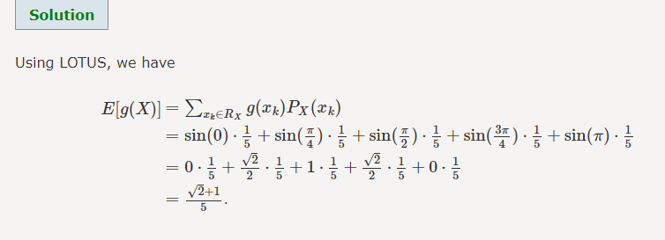

Example
Prove E[aX+b]=aEX+b�[��+�]=���+� (linearity of expectation).

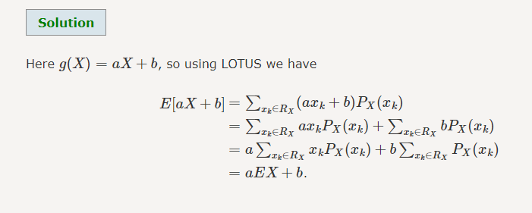

3.2.4 Variance
Consider two random variables X� and Y� with the following PMFs.

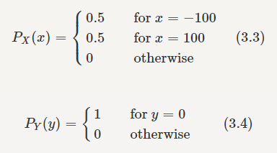

Note that EX=EY=0��=��=0. Although both random variables have the same mean value, their distribution is completely different. Y� is always equal to its mean of 00, while X� is either 100100 or −100−100, quite far from its mean value. The variance is a measure of how spread out the distribution of a random variable is. Here, the variance of Y� is quite small since its distribution is concentrated at a single value, while the variance of X� will be larger since its distribution is more spread out.

The variance of a random variable X�, with mean EX=μX��=��, is defined as

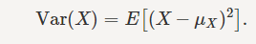

By definition, the variance of X� is the average value of (X−μX)2(�−��)2. Since (X−μX)2≥0(�−��)2≥0, the variance is always larger than or equal to zero. A large value of the variance means that (X−μX)2(�−��)2 is often large, so X� often takes values far from its mean. This means that the distribution is very spread out. On the other hand, a low variance means that the distribution is concentrated around its average.

Note that if we did not square the difference between X� and its mean, the result would be 00. That is
X� is sometimes below its average and sometimes above its average. Thus, X−μX�−�� is sometimes negative and sometimes positive, but on average it is zero.

To compute Var(X)=E[(X−μX)2]���(�)=�[(�−��)2], note that we need to find the expected value of g(X)=(X−μX)2�(�)=(�−��)2, so we can use LOTUS. In particular, we can write

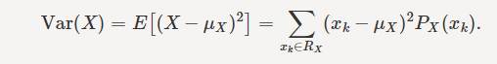

For example, for X� and Y� defined in Equations 3.3 and 3.4, we have
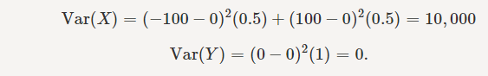

As we expect, X� has a very large variance while Var(Y)=0(�)=0.
Note that Var(X)(�) has a different unit than X�. For example, if X� is measured in meters������ then Var(X)(�) is in meters2������2. To solve this issue, we define another measure, called the standard deviation, usually shown as σX��, which is simply the square root of variance.

The standard deviation of a random variable X� is defined as
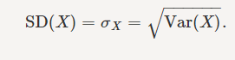

The standard deviation of X� has the same unit as X�. For X� and Y� defined in Equations 3.3 and 3.4, we have
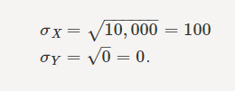
Here is a useful formula for computing the variance.

Computational formula for the variance:
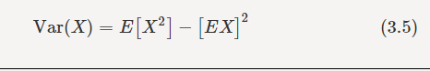

To prove it note that
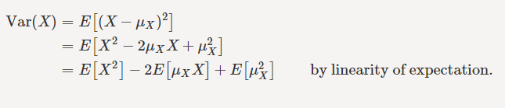
Note that for a given random variable X�, μX�� is just a constant real number. Thus, E[μXX]=μXE[X]=μ2X�[���]=���[�]=��2, and E[μ2X]=μ2X�[��2]=��2, so we have

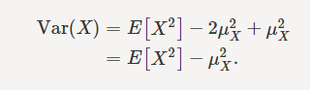

Equation 3.5 is usually easier to work with compared to Var(X)=E[(X−μX)2]Var(�)=�[(�−��)2]. To use this equation, we can find E[X2]=EX2�[�2]=��2 using LOTUS

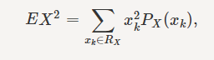

and then subtract μ2X��2 to obtain the variance.

Example
I roll a fair die and let X� be the resulting number. Find EX��, Var(X)(�), and σX

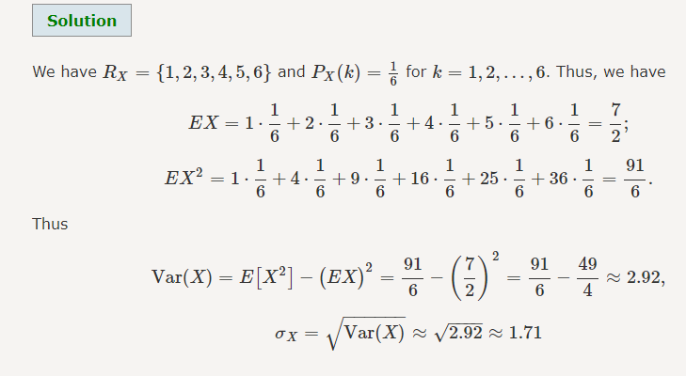
Note that variance is not a linear operator. In particular, we have the following theorem.
Theorem
For a random variable X� and real numbers a� and b�,


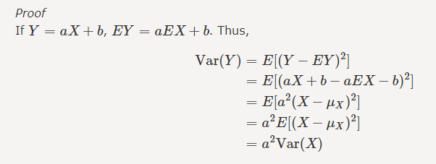

From Equation 3.6, we conclude that, for standard deviation, SD(aX+b)=|a|SD(X)SD(��+�)=|�|SD(�). We mentioned that variance is NOT a linear operation. But there is a very important case, in which variance behaves like a linear operation and that is when we look at sum of independent random variables.
Theorem
If X1,X2,⋯,Xn�1,�2,⋯,�� are independent random variables and X=X1+X2+⋯+Xn�=�1+�2+⋯+��, then
We will prove this theorem in Chapter 6, but for now we can look at an example to see how we can use it.

Example
If X∼Binomial(n,p)�∼��������(�,�) find Var(X)(�).

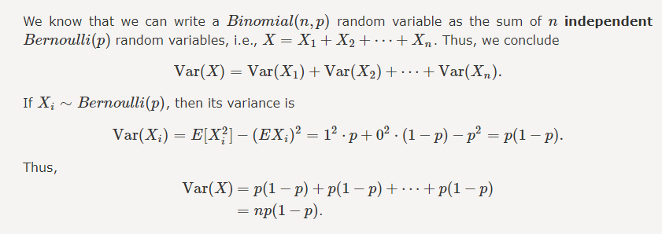

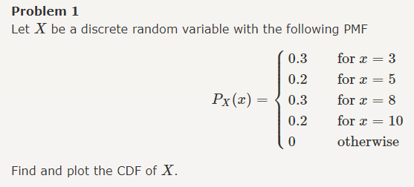
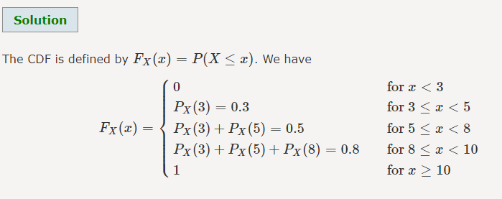

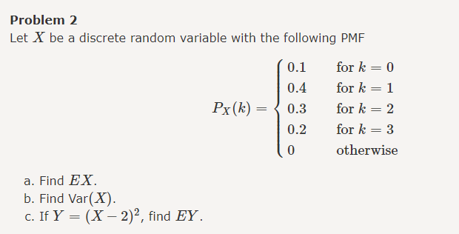

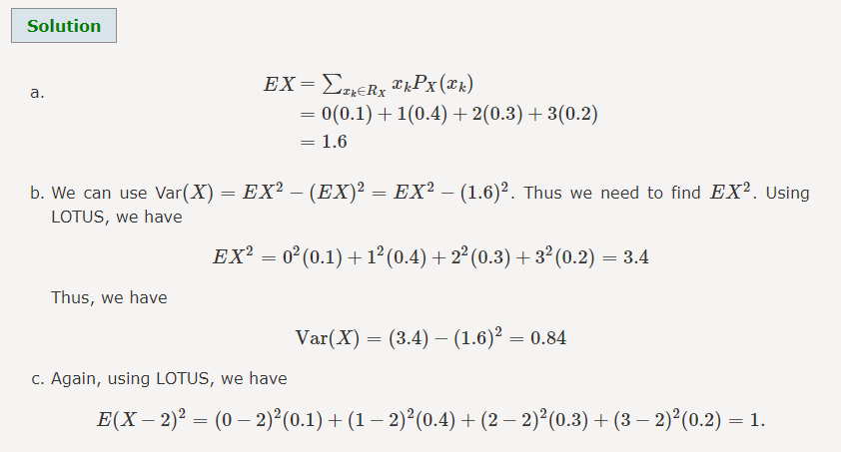

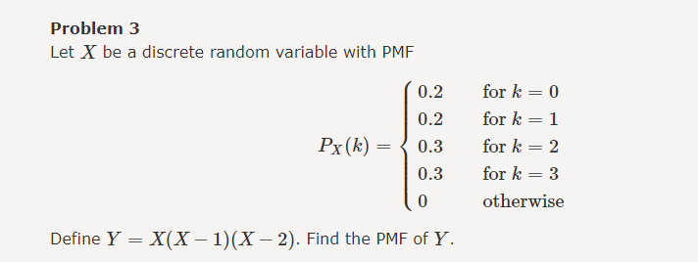

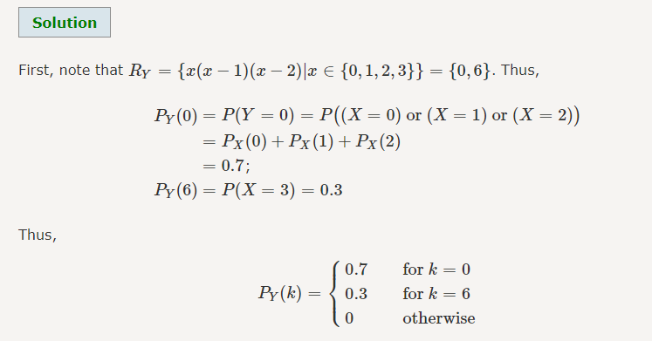
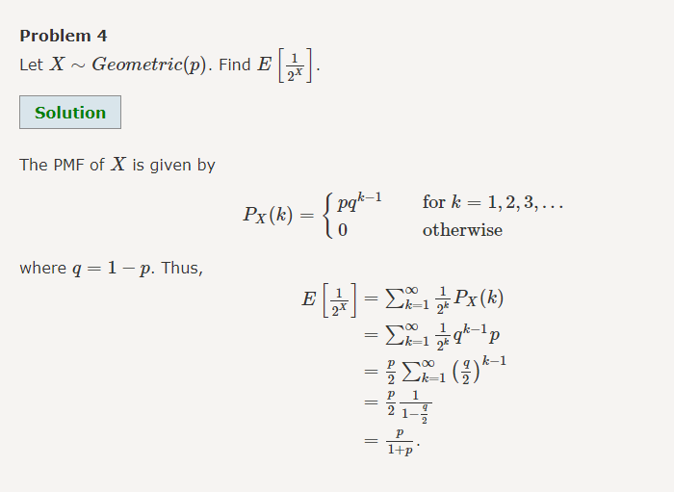

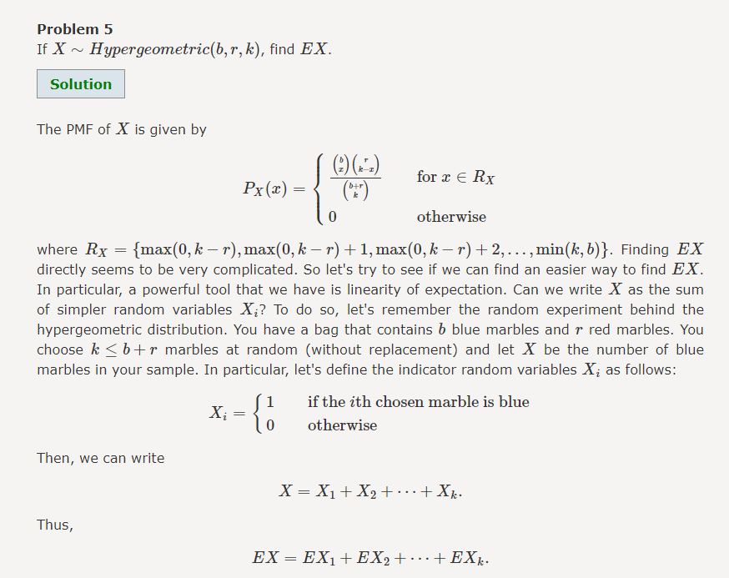

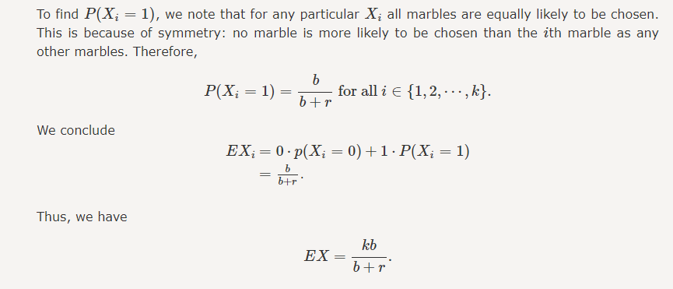

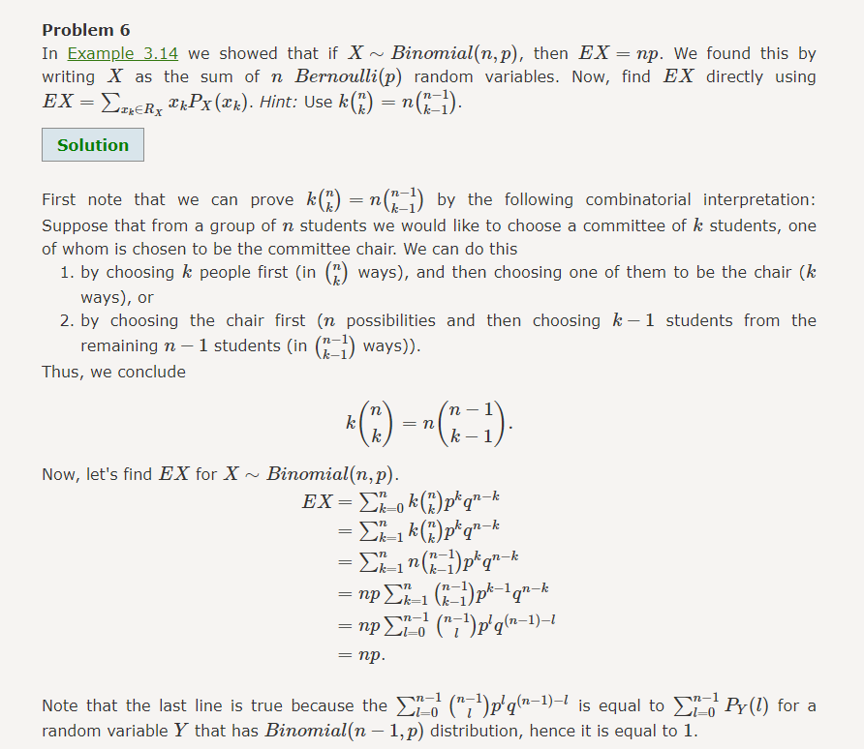

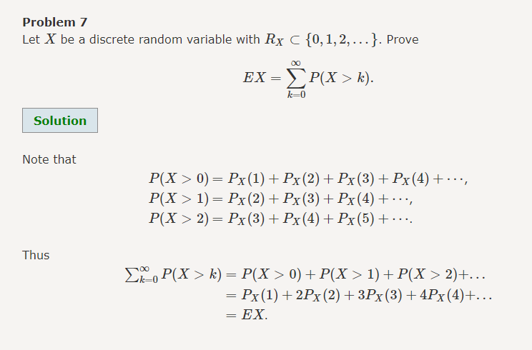

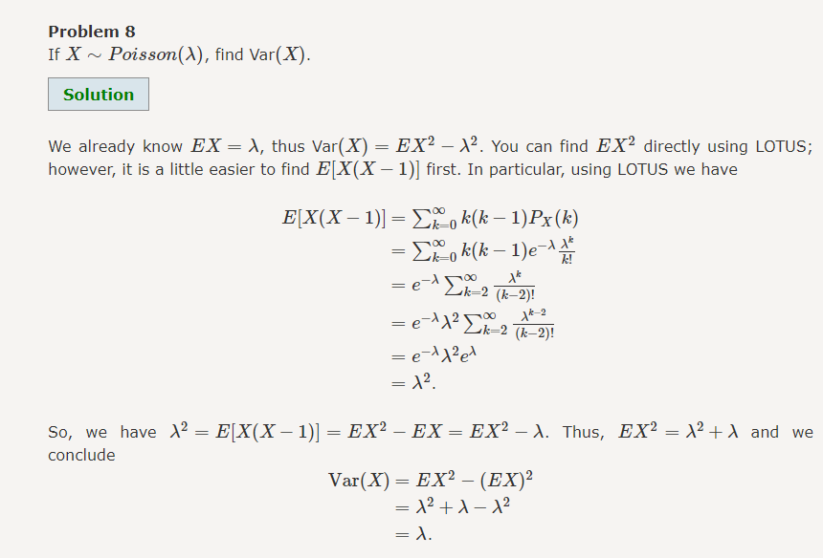

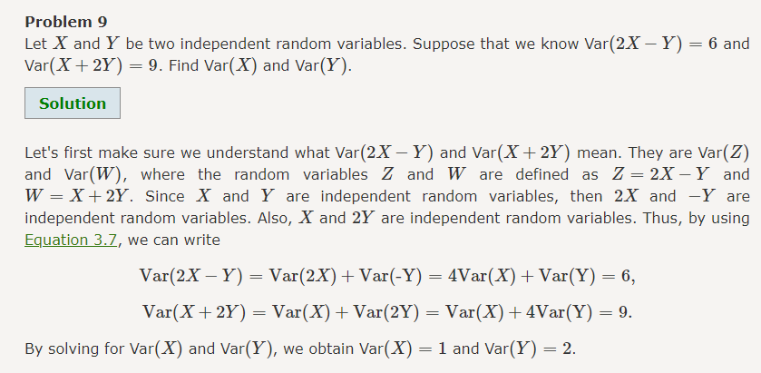
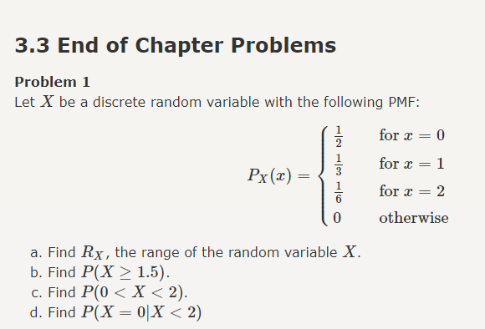
Problem
Let X� be the number of the cars being repaired at a repair shop. We have the following information:
- At any time, there are at most 33 cars being repaired.
- The probability of having 22 cars at the shop is the same as the probability of having one car.
- The probability of having no car at the shop is the same as the probability of having 33 cars.
- The probability of having 11 or 22 cars is half of the probability of having 00 or 33 cars.
Find the PMF of X�.

Problem
I roll two dice and observe two numbers X� and Y�. If Z=X−Y�=�−�, find the range and PMF of Z�.

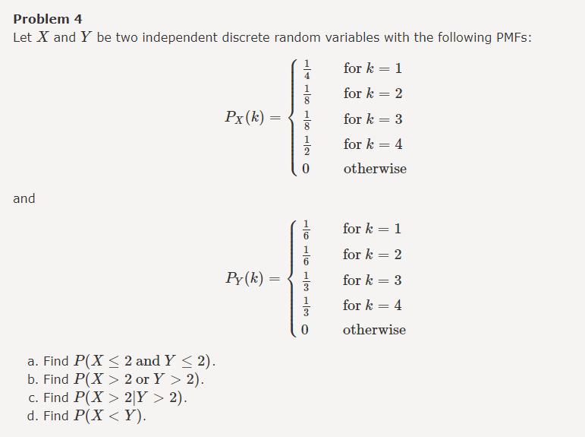

Problem
5050 students live in a dormitory. The parking lot has the capacity for 3030 cars. If each student has a car with probability 1212 (independently from other students), what is the probability that there won't be enough parking spaces for all the cars?

Problem (The Matching Problem)
N� guests arrive at a party. Each person is wearing a hat. We collect all the hats and then randomly redistribute the hats, giving each person one of the N� hats randomly. Let XN�� be the number of people who receive their own hats. Find the PMF of XN��.
Hint: We previously found that (Problem 7 in Section 2.1.5)
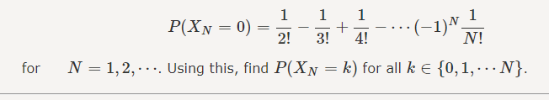

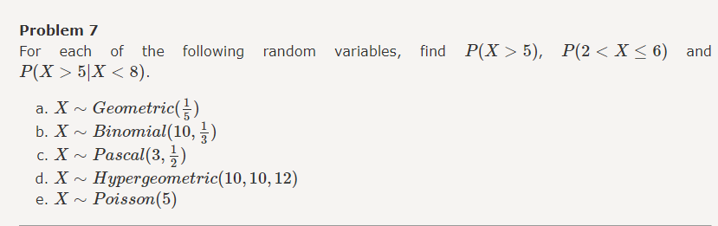

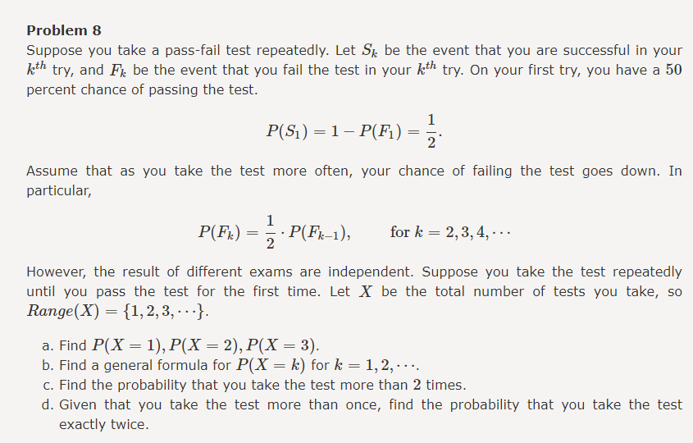
Problem
In this problem, we would like to show that the geometric random variable is memoryless. Let X∼Geometric(p)�∼���������(�). Show that
P(X>m+l|X>m)=P(X>l), for m,l∈{1,2,3,⋯}.�(�>�+�|�>�)=�(�>�), for �,�∈{1,2,3,⋯}.
We can interpret this in the following way: Remember that a geometric random variable can be obtained by tossing a coin repeatedly until observing the first heads. If we toss the coin several times, and do not observe a heads, from now on it is like we start all over again. In other words, the failed coin tosses do not impact the distribution of waiting time from this point forward. The reason for this is that the coin tosses are independent.

Problem
An urn consists of 2020 red balls and 3030 green balls. We choose 1010 balls at random from the urn. The sampling is done without replacement (repetition not allowed).
- What is the probability that there will be exactly 44 red balls among the chosen balls?
- Given that there are at least 33 red balls among the chosen balls, what is the probability that there are exactly 44 red balls?
Problem
The number of emails that I get in a weekday (Monday through Friday) can be modeled by a Poisson distribution with an average of 1616 emails per minute. The number of emails that I receive on weekends (Saturday and Sunday) can be modeled by a Poisson distribution with an average of 130130 emails per minute.
- What is the probability that I get no emails in an interval of length 44 hours on a Sunday?
- A random day is chosen (all days of the week are equally likely to be selected), and a random interval of length one hour is selected on the chosen day. It is observed that I did not receive any emails in that interval. What is the probability that the chosen day is a weekday?
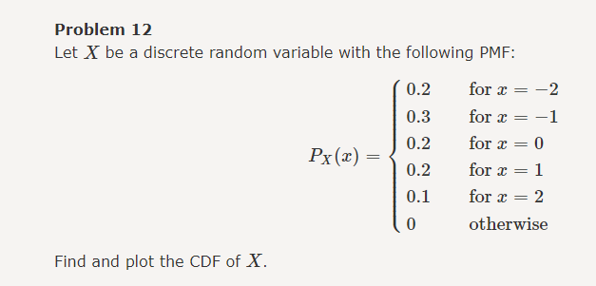

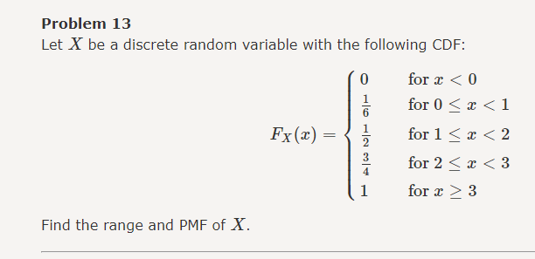

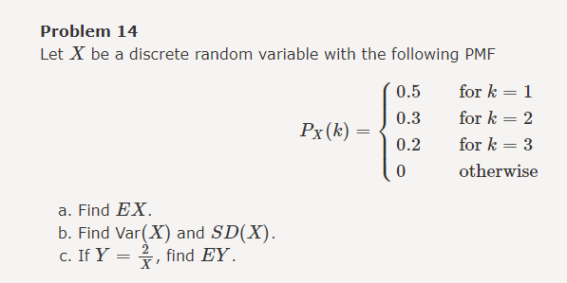

Problem
Let X∼Geometric(13)�∼���������(13), and let Y=|X−5|�=|�−5|. Find the range and PMF of Y�

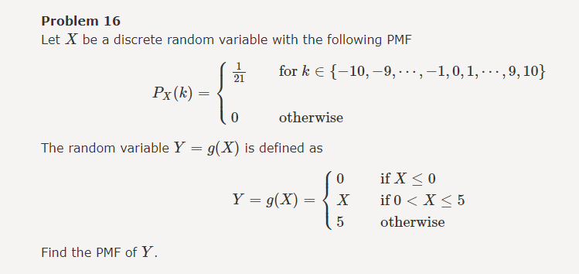

Problem
Let X∼Geometric(p)�∼���������(�). Find Var(X)���(�).

Problem
Let X∼Pascal(m,p)�∼������(�,�). Find Var(X)���(�).

Problem
Suppose that Y=−2X+3�=−2�+3. If we know EY=1��=1 and EY2=9��2=9, find EX�� and Var(X)���(�).

Problem
There are 10001000 households in a town. Specifically, there are 100100 households with one member, 200200 households with 2 members, 300300 households with 33 members, 200200 households with 4 members, 100100 households with 5 members, and 100100 households with 66 members. Thus, the total number of people living in the town is
N=100⋅1+200⋅2+300⋅3+200⋅4+100⋅5+100⋅6=3300.�=100⋅1+200⋅2+300⋅3+200⋅4+100⋅5+100⋅6=3300.
- We pick a household at random, and define the random variable X� as the number of people in the chosen household. Find the PMF and the expected value of X�.
- We pick a person in the town at random, and define the random variable Y� as the number of people in the household where the chosen person lives. Find the PMF and the expected value of Y�.

Problem (Coupon collector's problem [8])
Suppose that there are N different types of coupons. Each time you get a coupon, it is equally likely to be any of the N possible types. Let X be the number of coupons you will need to get before having observed each coupon at least once.
- Show that you can write X=X0+X1+⋯+XN−1�=�0+�1+⋯+��−1 , where Xi∼Geometric(N−iN)��∼���������(�−��).
- Find EX.

Problem (St. Petersburg Paradox [9])
Here is a famous problem called the St. Petersburg Paradox. Wikipedia states the problem as follows: "A casino offers a game of chance for a single player in which a fair coin is tossed at each stage. The pot starts at 11 dollar and is doubled every time a head appears. The first time a tail appears, the game ends and the player wins whatever is in the pot. Thus the player wins 1 dollar if a tail appears on the first toss, 2 dollars if a head appears on the first toss and a tail on the second, 44 dollars if a head appears on the first two tosses and a tail on the third, 8 dollars if a head appears on the first three tosses and a tail on the fourth, and so on. In short, the player wins 2k−12�−1 dollars if the coin is tossed k� times until the first tail appears. What would be a fair price to pay the casino for entering the game?"
- Let X� be the amount of money (in dollars) that the player wins. Find EX��.
- What is the probability that the player wins more than 6565 dollars?
- Now suppose that the casino only has a finite amount of money. Specifically, suppose that the maximum amount of the money that the casion will pay you is 230230 dollars (around 1.07 billion dollars). That is, if you win more than 230230 dollars, the casino is going to pay you only 230230 dollars. Let Y� be the money that the player wins in this case. Find EY��.
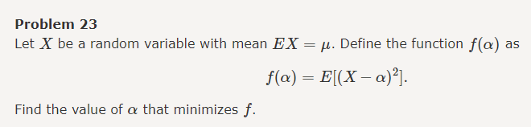

Problem
You are offered to play the following game. You roll a fair die once and observe the result which is shown by the random variable X�. At this point, you can stop the game and win X� dollars. You can also choose to roll the die for the second time to observe the value Y�. In this case, you will win Y� dollars. Let W� be the value that you win in this game. What strategy do you use to maximize EW��? What is the maximum EW�� you can achieve using your strategy?

